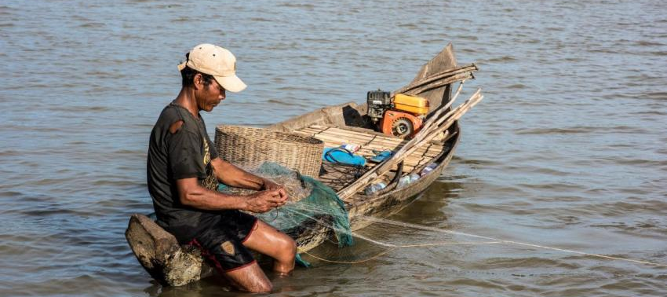
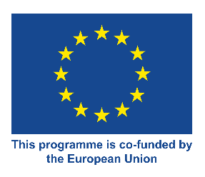
CAPFISH-Capture
QUARTERLY STATISTICAL REPORT

Inland Fisheries

©Finn Thilsted WorldFish Flicker
Statistical Report for Scientific Catch Assessment of Inland Fisheries in Cambodia

July - September 2021

Prepared by Inland Fisheries Research and Development Institute

This publication was produced with the financial support of the European Union. Its contents are the sole responsibility of
Fisheries Administration and do not necessarily reflect the views of the European Union

This publication was produced with the financial support of the European Union.
Its contents are the sole responsibility of Fisheries Administration and do not necessarily reflect the views of the European Union

- Introduction and methodology

IFReDI, with technical assistance from FAO CAPFISH project under EU budget support, is currently piloting scientific catch assessment using a monthly household recall survey for 900 households, covering all provinces in Cambodia. The aim is to obtain better information on catch and effort by small-scale household fisheries in Cambodia, and to develop a sustainable catch monitoring methodology for implementation by provincial fisheries administrations, supported by IFReDI.

Data collection started in June 2021 as part of a field training for IFReDI and FiAC staff and coverage has been gradually expanded since then. This quarterly report covers July – September 2021 and is based on the monthly statistical reports for that period.

A description of the methodology can be found in:
Fisheries Administration (FiA). 2021. Manual for Scientific Catch Assessment by Recall survey of Inland Fisheries in Cambodia. Inland Fisheries Research and Development Institute of the Fisheries Administration, Phnom Penh, Cambodia. 47 pages.

- Statistical tables and results

The coverage for data collection from July to September 2021, included in Table 1, has gradually increased from 24.4% of the target household sample in July to 49.9% in September 2021.

Table 1. Number of random selected households covered by the survey and proportion of target household by fishing area for July - September 2021.
Fishing Area | Villages |  |  |  | Households
 | Jul | Aug | Sep | Target | Jul | Aug | Sep | Target
Coastal | - | - | - | 4 | - | - | - | 60
Floodplain | 4 | 12 | 12 | 21 | 58 | 168 | 181 | 315
Mountainous | - | 1 | 2 | 7 | - | 12 | 24 | 105
Plateau | 3 | 6 | 6 | 7 | 24 | 126 | 90 | 105
Tonle Sap | 8 | 11 | 11 | 21 | 138 | 128 | 154 | 315
Total | 15 | 30 | 31 | 60 | 220 | 434 | 449 | 900
 | 25.0% | 50.0% | 51.7% |  | 24.4% | 48.2% | 49.9%

The limited increase in numbers of households interviewed, from August to September, has led to a decision by FiA to mobilise more field staff for October, this will focus on expanding the sample coverage to all target villages and households.

The effects of a relative low sample size during July 2021, can be clearly seen from the lack of statistical accuracy (precision) of the estimates for the daily and total estimated catch, for floodplain and Tonle Sap fishing areas, in Table 2 and Table 3. Ideally, the CPUE (expressed as average daily household catch) and total estimated catch, have a relative error of less than 20%.

The observed daily household catch for floodplain and plateau fishing area households are comparable at less than 2 kg/HH/day, while it is about double for households in the Tonle Sap fishing area. The daily household catch for mountainous households cannot yet be reliably assessed.

Table 2. Mean daily household catch (CPUE), red font indicates CPUE with relative standard error >20%.
Fishing Area | % Active HH |  |  | Daily HH catch (Kg)
 | Jul | Aug | Sep | Jul | Aug | Sep
Coastal | - | - | - | - | - | -
Floodplain | 27.6% | 19.0% | 29.8% | 2.96 | 1.81 | 1.55
Mountainous | - | 25.0% | 29.2% |  | 0.53 | 1.90
Plateau | 66.7% | 54.0% | 48.9% | 1.31 | 1.75 | 1.94
Tonle Sap | 40.6% | 48.4% | 65.6% | 5.00 | 3.17 | 3.58
Overall | 40.0% | 38.0% | 45.9% | 3.99 | 2.27 | 2.64

In view of the high relative error (Table 3), caused by a high variation in the reported catch and incomplete sample, for both the floodplain and Tonle Sap fishing areas, the total estimated catch for July 2021 is not reliable. This is less of an issue for August and September, where only the estimates for mountainous and plateau fishing areas are affected, who contribute around 5% of the total estimated catch. The observed values for the relative standard error indicates that the variation in fish catches may require an increase in the sample size.

Table 3. Total estimated catch by fishing area, red font indicates estimates with a relative standard error of >20%.
Fishing Area | July |  | August |  | September |  | Catch proportion
 | Catch (MT) | ε% | Catch (MT) | ε% | Catch (MT) | ε%
Coastal | - |  | - |  | - |  | -
Floodplain | 11,858 | 47.0% | 4,996 | 14.6% | 5,499 | 13.9% | 24.6%
Mountainous |  |  | 97 | 31.6% | 960 | 29.4% | 1.2%
Plateau | 1,798 | 19.0% | 2,205 | 13.7% | 2,187 | 30.2% | 6.8%
Tonle Sap | 27,503 | 40.8% | 13,276 | 19.8% | 20,535 | 11.8% | 67.4%
Total | 41,159 |  | 20,574 |  | 29,181
ε% is relative Standard Error

During August and September, less than 50% of the target sample size was interviewed, which means that the available data doesn’t yet represent the entire fisheries. In addition, both floodplain and mountainous fishing areas, see a relative low proportion of active fishing households, which may add further increases to the required sample size. Until the CAS has been implemented for a full 12-month period, adjustments to the required sample size (which may involve seasonal variation to coverage and stratification) cannot yet be ascertained. The variation in the reported catches will differ between months and fishing areas, based on the characteristics of the fisheries, as fishing operations (gear use and fishing grounds) will shift.

Overall the catches from Tonle Sap represent close to 70% of the total estimated catch, with floodplain fishing area adding almost 25%.

Figure 1. Catch contribution for fish and other aquatic animals

ក្រាហ្វីកទី១. ការចូលរួមចំណែកផលចាប់ រវាងត្រីនិងវារីសត្វផ្សេងទៀត

The available data shows that fish represents the bulk of the reported catches. OAA availability is seasonal, but the observed proportion is in agreement with previous findings by IFReDI based on consumption studies, that OAA represents less than 10% of the total inland yield.

Catch by species is shown in Table 4. Three points are worth mentioning:
- Non-specific species, the grouping other fish not elsewhere included (nei), only represents 6.6%;
- The only non-fish species (OAA) in the top 20 is a crab (Somanniathelpusa brandti); and,
- A total of 107 species and species groups are included in the data with the top 20 representing 75% of the total catch, the top 3 species in the catch represent almost 27% of the catch.

The high specificity in the reported catches provides some confidence in the reported species catches, which are based entirely on Khmer local names. Only the floodplain, plateau and Tonle Sap fisheries are sufficiently represented during July-September 2021, full coverage may slightly affect the species contribution. However, since mountainous and coastal fishing areas are not expected to contribute more than 5% of the total estimated catch, this is not expected to affect the species contribution significantly.

Table 4. Top 20 reported species catch for top 20 species by weight for July-September 2021, with reported weight and proportion of catch by individual species and species groups.
 | Scientific name | catch (kg) | Catch contribution
 |  |  | Proportion | Cumulative
1 | Clarias batrachus | 508.3 | 11.6% | 11.6%
2 | Anabas testudineus | 356.4 | 8.1% | 19.7%
3 | Channa striata | 303.9 | 6.9% | 26.6%
4 | Other fish nei | 291.1 | 6.6% | 33.3%
5 | Oxyeleotris marmorata | 225.8 | 5.1% | 38.4%
6 | Puntioplites proctozysron | 201.8 | 4.6% | 43.0%
7 | Mystus mysticetus / Mystus bocourti | 157.3 | 3.6% | 46.6%
8 | Labiobarbus siamensis | 151.8 | 3.5% | 50.0%
9 | Henicorhynchus siamensis | 126.6 | 2.9% | 52.9%
10 | Cyclocheilichthys repasson | 124.0 | 2.8% | 55.8%
11 | Somanniathelpusa brandti | 112.5 | 2.6% | 58.3%
12 | Henicorhynchus lobatus | 112.1 | 2.6% | 60.9%
13 | Trichopodus microlepis | 87.9 | 2.0% | 62.9%
14 | Hemibagrus spilopterus | 85.7 | 2.0% | 64.8%
15 | Puntioplites falcifer | 82.9 | 1.9% | 66.7%
16 | Cyclocheilichthys enoplos | 79.6 | 1.8% | 68.5%
17 | Paralaubuca typus | 79.1 | 1.8% | 70.3%
18 | Henicorhynchus sp. | 68.0 | 1.5% | 71.9%
19 | Barbonymus gonionotus | 67.4 | 1.5% | 73.4%
20 | Other species | 1166.6 | 26.6% | 100.0%

The highest species diversity is found for August, while for the 3-month period, both plateau and Tonle Sap have a similar number of species in the catches. Since not all fishing areas are fully covered and the data only covers the first 3 months of the survey no in-depth comparison between months or contribution by main fish assemblage groups is presented.

Table 5. Number of species in reported catch by month and fishing area.
Fishing Area | July | August | September | Unique Species
Coastal
Floodplain | 23 | 38 | 36 | 56
Mountainous |  | 5 | 4 | 8
Plateau | 35 | 75 | 40 | 86
Tonle Sap | 51 | 49 | 57 | 78
Unique species | 69 | 92 | 80 | 107
Table 6. Top 20 reported species by value (1000 Riel) in reported catch, with reported value, proportion of value by individual species and species groups.
 | Scientific name |  | Value  (1000 Riel) | Value Contribution
 |  |  |  | Proportion | Cumulative
1 |  | Clarias batrachus | 4195.9 | 14.2% | 14.2%
2 |  | Channa striata | 3646.8 | 12.4% | 26.6%
3 |  | Anabas testudineus | 2864.9 | 9.7% | 36.3%
4 |  | Other fish nei | 2542.7 | 8.6% | 45.0%
5 |  | Mystus mysticetus / Mystus bocourti | 1434.6 | 4.9% | 49.8%
6 |  | Puntioplites proctozysron | 1297.5 | 4.4% | 54.2%
7 |  | Oxyeleotris marmorata | 1278.5 | 4.3% | 58.6%
8 |  | Labiobarbus siamensis | 1005.6 | 3.4% | 62.0%
9 |  | Henicorhynchus siamensis | 978.9 | 3.3% | 65.3%
10 |  | Hemibagrus spilopterus | 910.0 | 3.1% | 68.4%
11 |  | Cyclocheilichthys repasson | 857.0 | 2.9% | 71.3%
12 |  | Cyclocheilichthys enoplos | 815.5 | 2.8% | 74.1%
13 |  | Henicorhynchus lobatus | 737.7 | 2.5% | 76.6%
14 |  | Puntioplites falcifer | 718.8 | 2.4% | 79.0%
15 |  | Paralaubuca typus | 657.6 | 2.2% | 81.2%
16 |  | Henicorhynchus sp. | 627.4 | 2.1% | 83.4%
17 |  | Gourami Trichopodus microlepis | 615.4 | 2.1% | 85.4%
18 |  | Barbonymus gonionotus | 573.4 | 1.9% | 87.4%
19 |  | Pangasius macronema | 467.3 | 1.6% | 89.0%
20 |  | Other species | 3249.2 | 11.0% | 100.0%

The reported catch by value, shows that despite some small shifts, due to higher prices for some species, the top 10 in Table 6, is virtually the same as by weight, included in Table 4. The top 20 species represents more than 90% of the total reported value, indicating that the number of species with high economic importance is fairly limited.

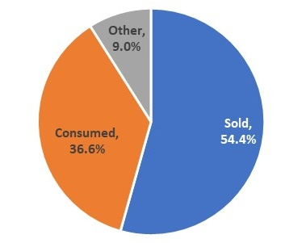
Figure 2. Catch disposal by main category for all fishing areas combined.
The disposal for all fishing areas combined (Figure 2), suggests that most of the reported catch is sold. This is somewhat skewed by the fish trade practices for the Tonle Sap fishing area, where almost 80% of the catch is sold. As can be seen (Table 7), fish trade is less important for floodplain and plateau fishing areas, where respectively 50% and 35% of the reported catch is sold and household consumption represents 42-48% respectively of the total reported catch. Household consumption covers all catch consumed fresh. Other use of the catch is mainly for processing, with some use in aquaculture or for animal rearing by households.

Table 7. Catch disposal compared between fishing areas.
 | Floodplain | Plateau | Tonle Sap
Sold | 50.0% | 34.6% | 78.5%
Consumed | 42.0% | 48.2% | 19.7%
Other | 8.0% | 17.2% | 1.8%

Catches are mainly caught using boats (Figure 3), with over half of the catch caught with motorised boats and an additional 14% with non-motorised boats. Catching without using a boat, i.e. near where households live represents 35% of the reported catch.

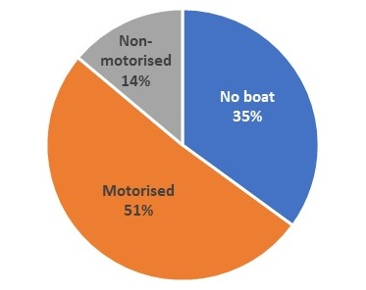
Figure 3. Proportion of catch reported by boat use category for all fishing areas combined,

Table 8. Proportion of catch reported by boat use category, by fishing area.
 | Floodplain | Plateau | Tonle Sap
No boat | 39.6% | 21.4% | 35.2%
Motorised | 27.3% | 49.9% | 53.9%
Non-motorised | 33.0% | 28.7% | 10.9%

As expected catch by motorised boats is most important for households fishing in Tonle Sap and plateau fishing areas (Table 8), whereas fishing without boats is somewhat more important for floodplain and Tonle Sap, compared to households in the plateau fishing area.

Species belonging to the genus of Henicorhynchus, when combined would be fourth by weight or about 7% of the total catch.
Referring to white fish, black fish and grey fish named after migratory behaviour and main habitats they can be found
This is based on calculated standardized weights for disposal categories based on the relative importance of total reported catches by fishing area.

